ADMISSION REQUIREMENTS
- Applicants must have reached at least Form 3 (Junior Certificate).
- Applicants must be between 18-35 years old.
- Graduates from high school and high school drop-outs who wish to pursue a vocational skill of their choice are encouraged to apply
- Applicant’s previous knowledge is highly recognized during admission.

TRAINING FEES
Tuition fee | 5000.00
Caution Fee (Refundable) | 200.00
Total | 5200.00

NB. Trainees are required to pay the training fees in FULL on or before the first day of Lectures. Fees paid are NOT refundable.

Applications
Application forms should be returned and hand delivered to the Receptionist at the Centre on or not later than 31st March 2026. Applicants will be invited for interviews on 15th April 2026. Applicants will be informed of their results via Email/and the Institutions notice board. Training will resume on 11th August 2026
VALUE STATEMENT
MITC is an accountable and transparent organization, which upholds principles of equity, child protection, gender equality and respect for all.
MITC MISSION STATEMENT
The mission of MITC is to provide market-driven quality technical and vocational education and training (TVET) cognizant of the National Qualifications Framework (NQF) through experiential learning of education with production for self-sustainable and gainful employment or out-of-school youth and adults, and the empowerment of socio-economically disadvantaged children.
COURSES OFFERED AT MITC
There are a variety of courses offered at MITC under the following trades: Agriculture, Auto Electrical, Building, Computer, Carpentry & joinery, Electrical installation, Metal work, Motor Mechanics, and Plumbing, Panel Beating and Spray Painting, Upholstery
The other trades are accredited by the Directorate of Industrial and Vocational Training (DIVT).
BACKGROUND INFORMATION
The Manzini Industrial Training Centre (MITC) Emakhonweni was set up to provide technical and vocational education and training (TVET) to young people whose ages range between eighteen (18) and thirty-five (35) in a vocational skill of their choice, to empower them for self-sustainable and gainful employment. MITC operates on the principle of “training through production”.
It is important for aspiring applicants to understand that MITC is a training institution; therefore those who enrol for any course are trainees, NOT students. Trainees are expected to possess such life skills as: self-directedness, self-reliance, resourcefulness, self-education, problem-solving abilities, and personality responsibility orientation.
MITC is gender-sensitive in all aspects of course enrolment; hence all the courses offered are open to women and men equally, without discrimination. In fact, women are urged to join the centre and venture into the man’s world of work.
VISION STATEMENT
The vision of MITC is to be the leading centre of excellence in technical and vocational career, and entrepreneurship training.
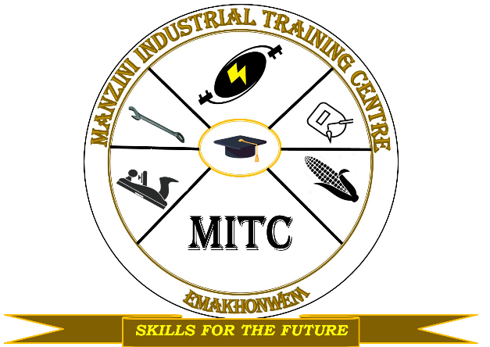


What is expected of the trainee?
Training is offered in an on-the-job training principle, and is conducted within a business-intensive environment. Therefore, punctuality and good attendance are essential. MITC has rules and regulations regarding health and safety which must be carefully observed at all times. A blue two-piece overall and safety boots with metal toe caps MUST be purchased and worn by each trainee everyday while attending training at the Centre.

“Training Young People for
Self-Employment”





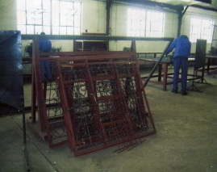

CONTACT DETAILS

The Centre Manager
Manzini Industrial Training Centre
PO Box 549 Manzini
Swaziland
Tel: (+268) 25052744/25052844
Fax: (+268) 25054083


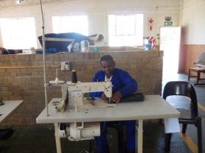

PROSPECTUS
2026/2027

